**---------Task 2---------------**

Git jenkins Docker RHEL 8 PHP

Task 2 Given By Mr. Vimal Daga Sir

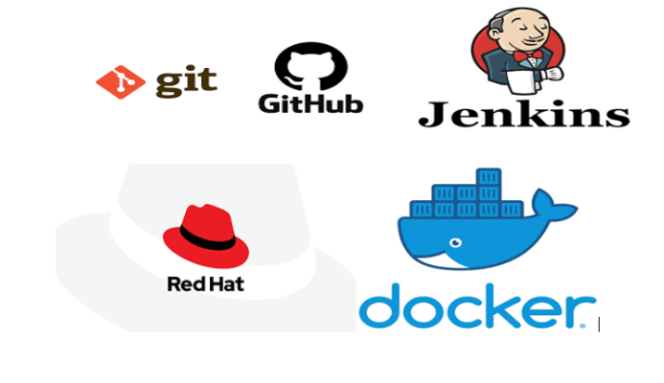

**Task Description :-**

1. Create container image that’s has Jenkins installed using dockerfile

2. When we launch this image, it should automatically starts Jenkins service in the container.

3. Create a job chain of job1, job2, job3 and job4 using build pipeline plugin in Jenkins

4. Job1 : Pull the Github repo automatically when some developers push repo to Github.

5. Job2 : By looking at the code or program file, Jenkins should automatically start the respective language interpreter installed image container to deploy code ( eg. If code is of PHP, then Jenkins should start the container that has PHP already installed ).

6. Job3 : Test your app if it is working or not.

7. Job4 : if app is not working , then send email to developer with error messages.

8. Create One extra job job5 for monitor : If container where app is running. fails due to any reson then this job should automatically start the container again.

**Pre-requisites For This Project :-**

- Base OS in my case it is Windows 10 and On the Top of Windows 10 I am using Red Hat Enterprise Linux (RHEL 8 ) with the Help of Virtual Box

- Inside Rhel we need some setup to be ready like we need docker , Jenkins , centos image like I am using centos latest and and using that image I have created one Dockerfile by installing some required softwares like httpd, java , git , php and some other packages and in this image so that we can use it furthur

Going Inside the Directory and seeing that where is our placed and then we will build that Dockerfile

--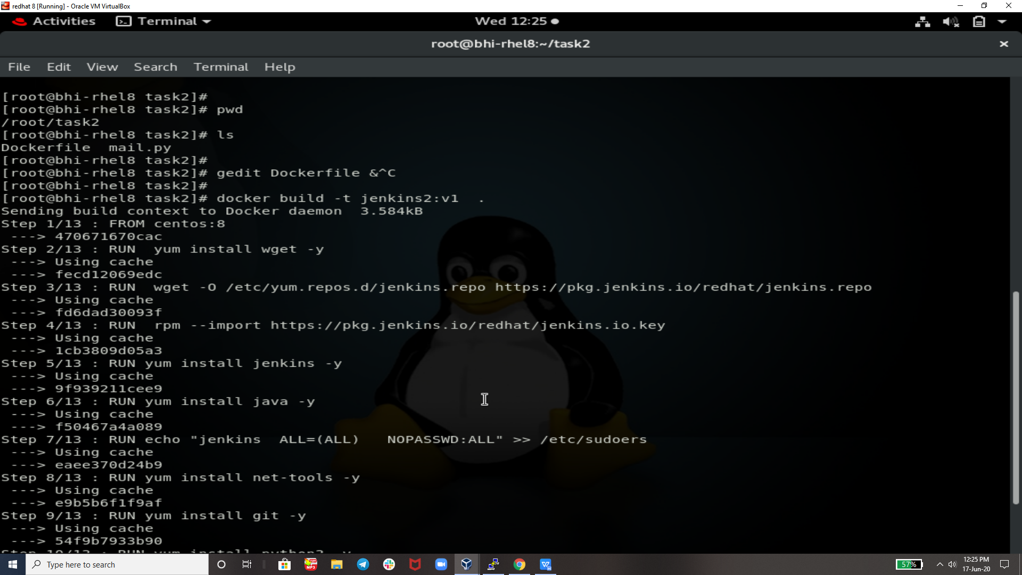

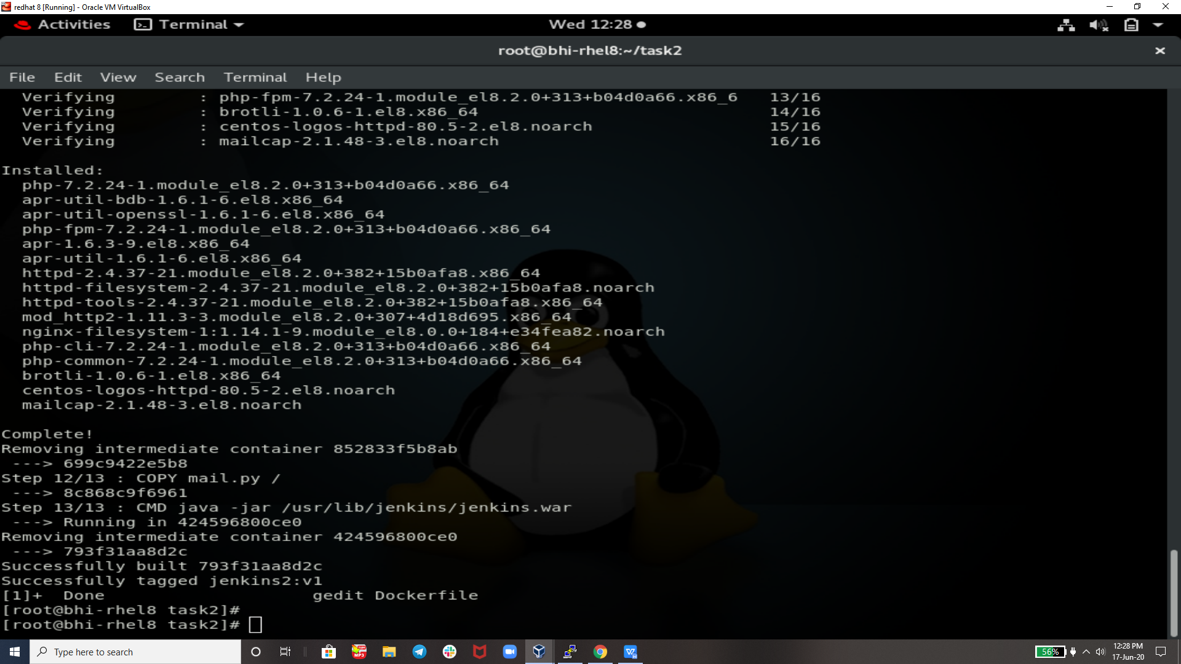

Docker Images That we will use in Future For Launching our Container s :-

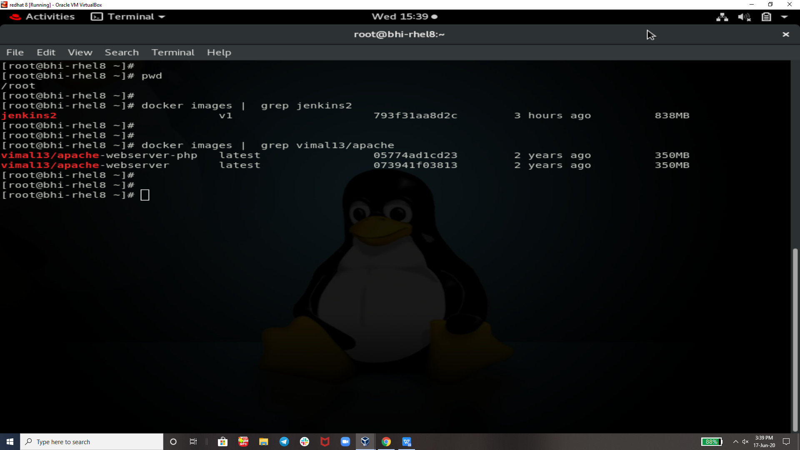

**Dockerfile used :-**

In this Dockerfile As u Ca See the Code that it will download java , jenkins , httpd , php,net-tools, git , python etc.

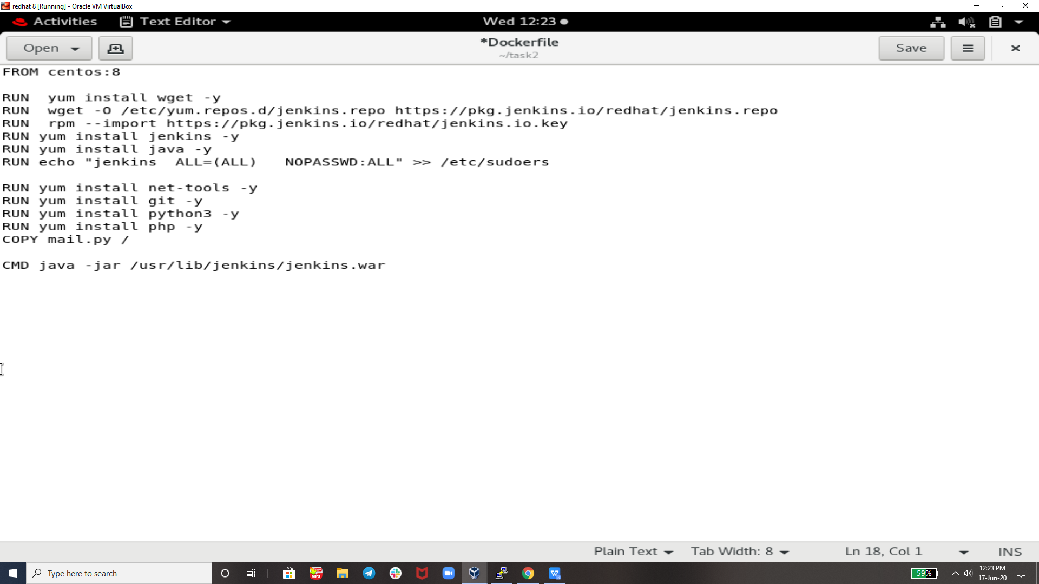

After Building Dockerdile launching one Container using this and then accessing jenkins using this .

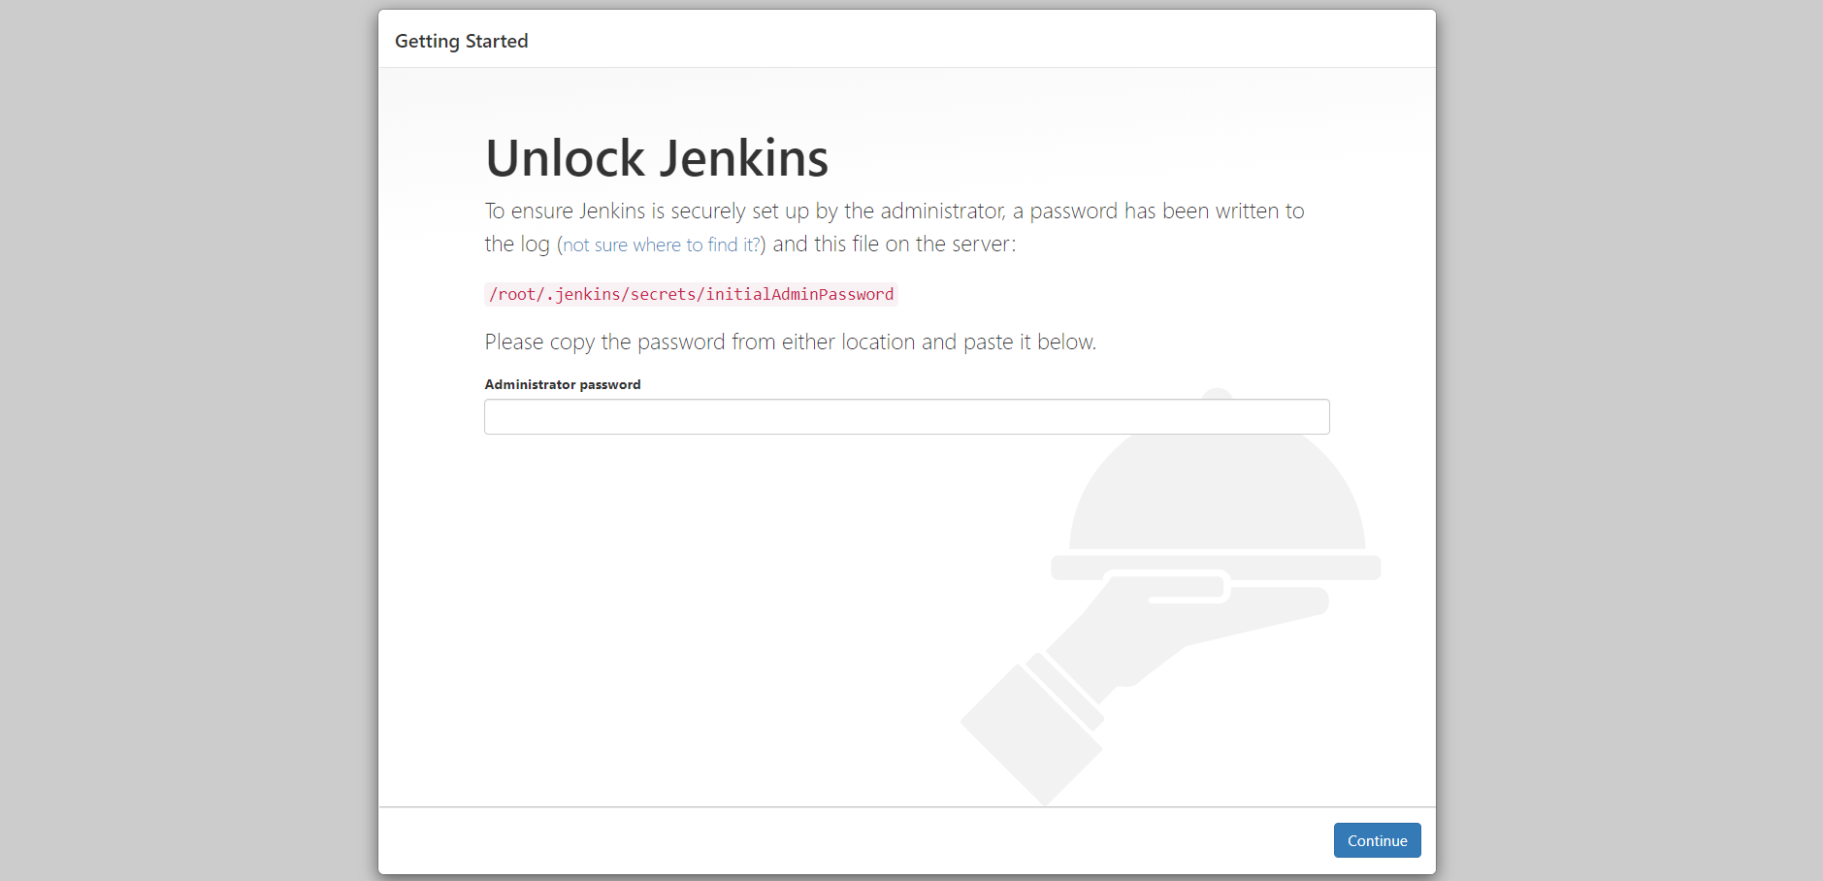

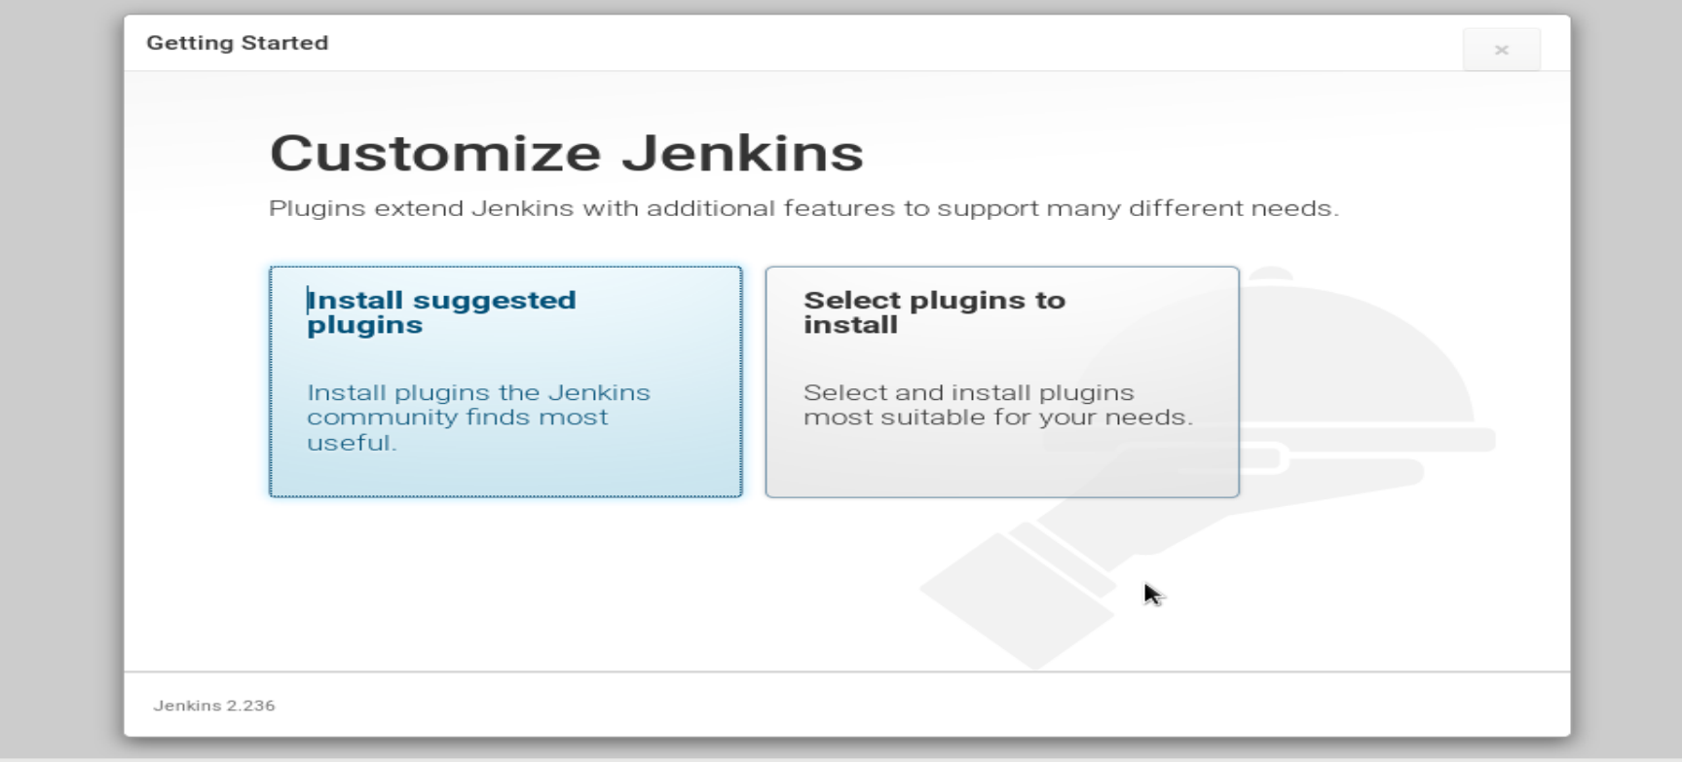

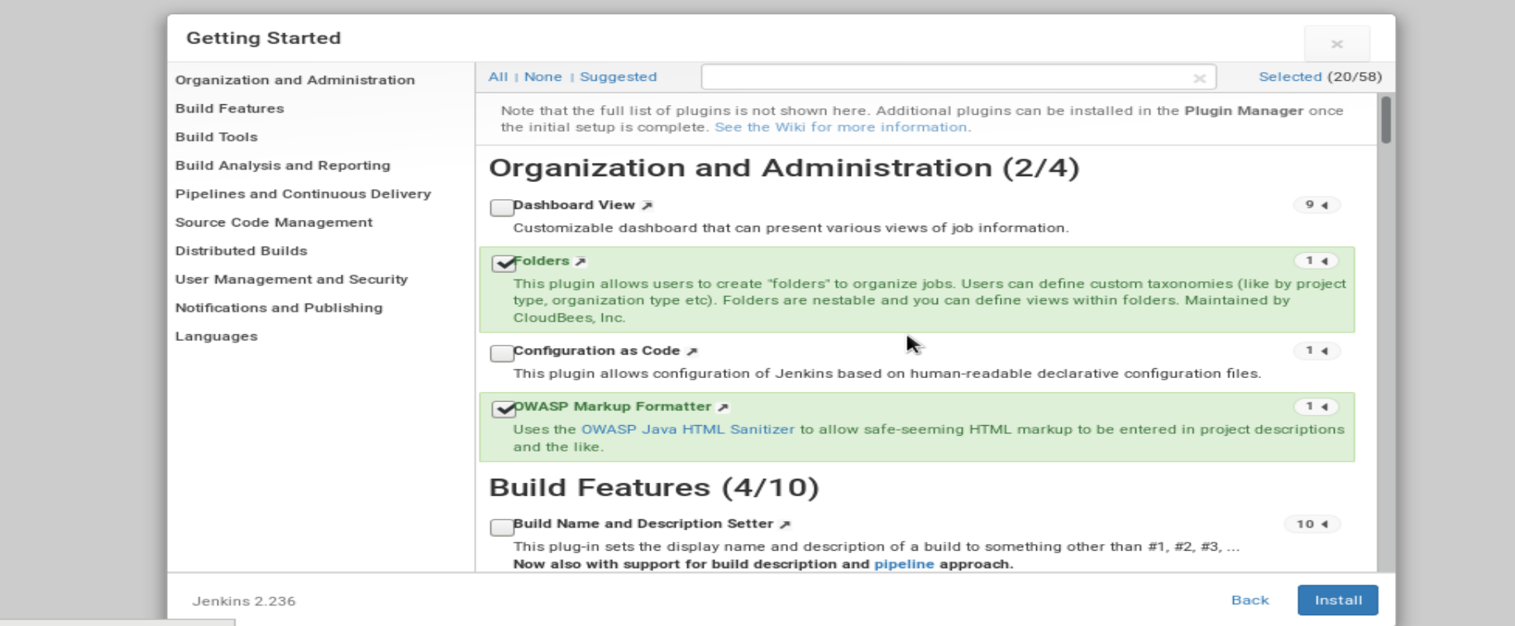

JOB1 :-

This Job will copy all the codes from GutHub Repo in given Direectory

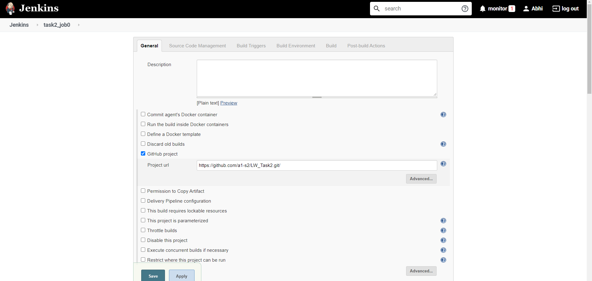

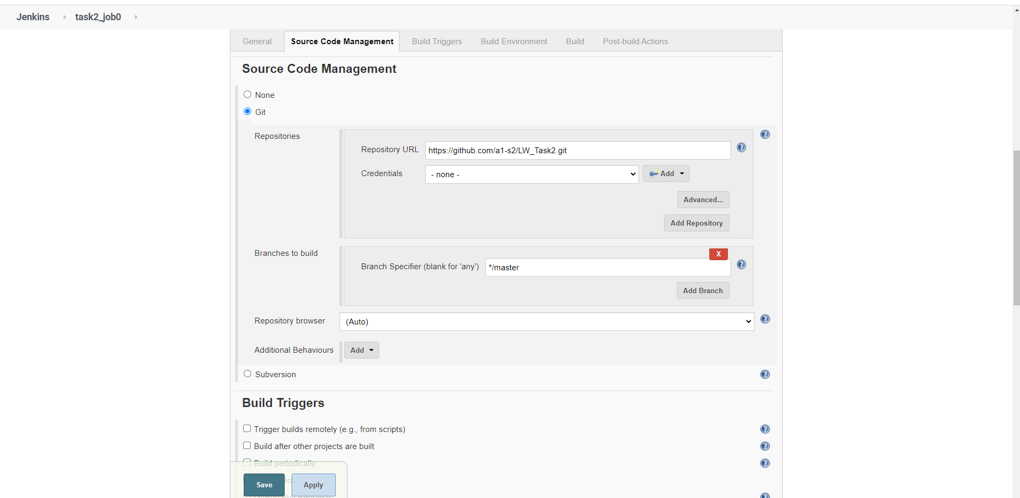

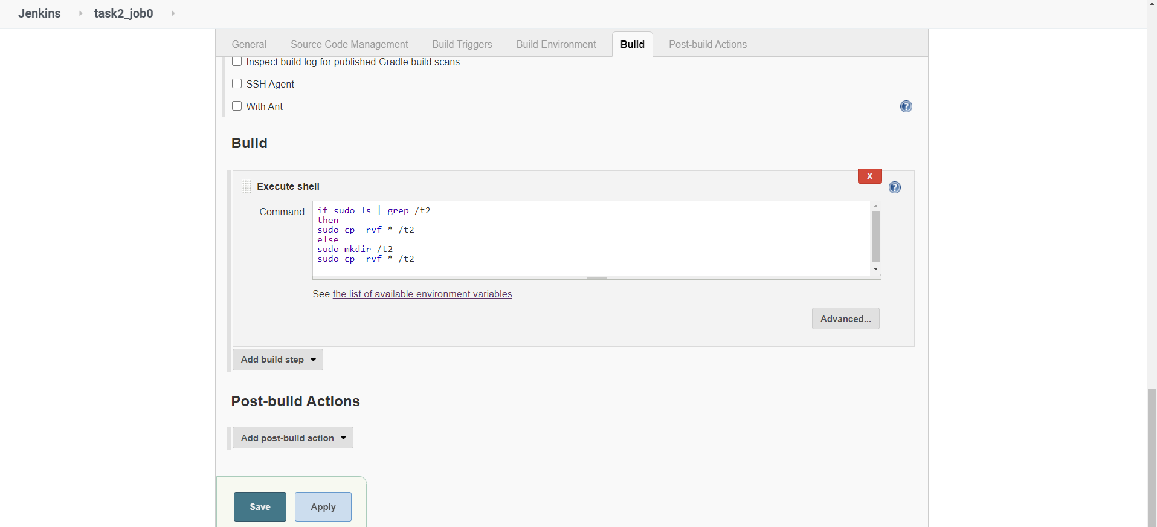

OutPuT of JOB 1:-

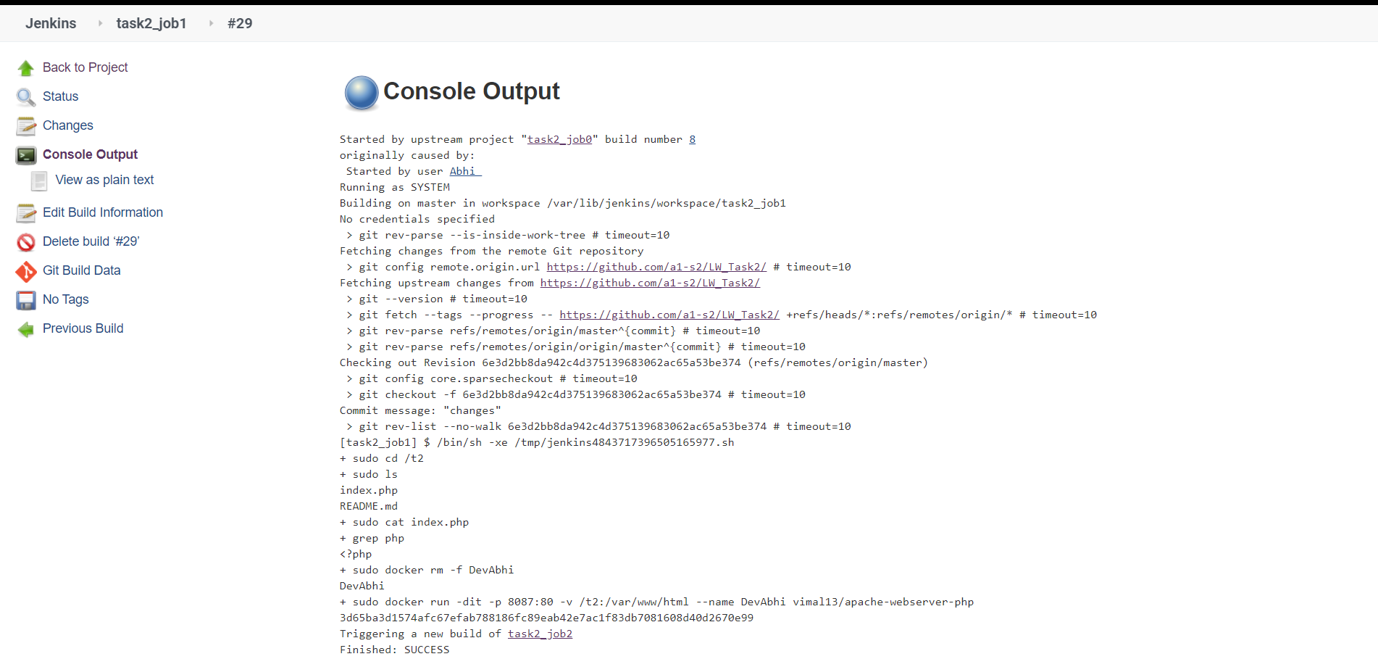

JOB2 :-

This job will be look for the code and check if php is their then it will go ahead and launch a container using a image that has already php installed I.e. vimal13/apache-webserver-php

.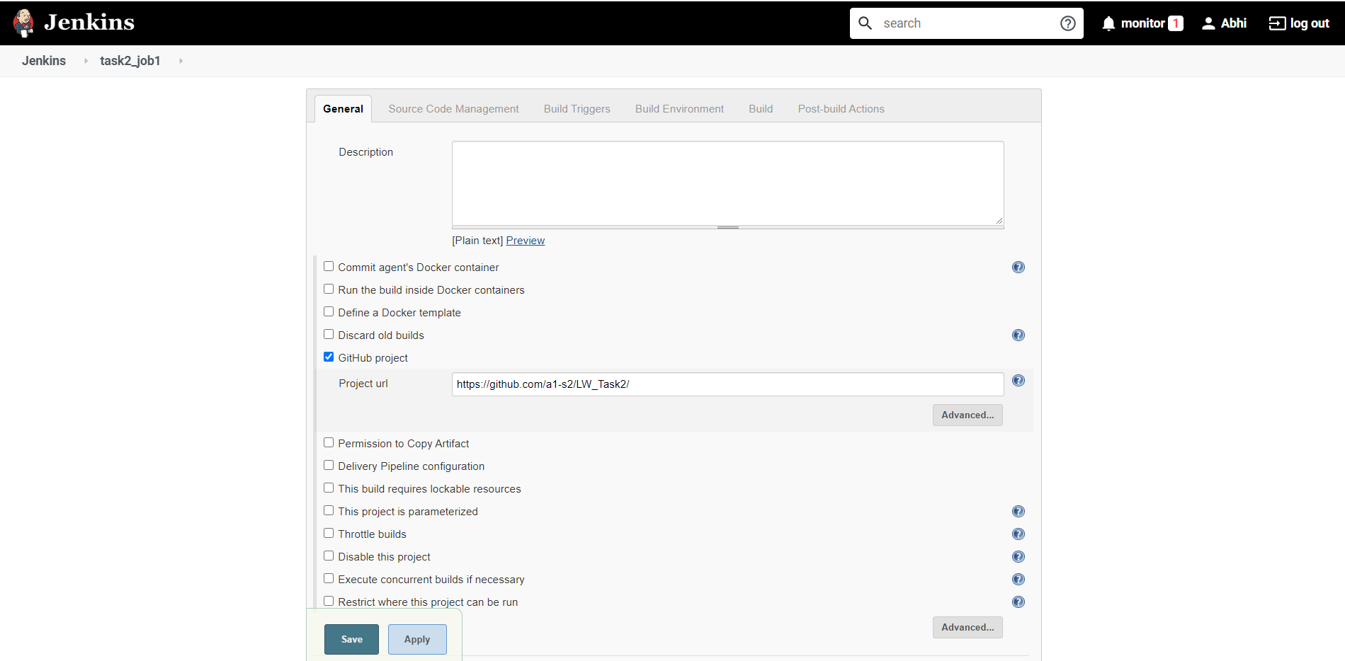

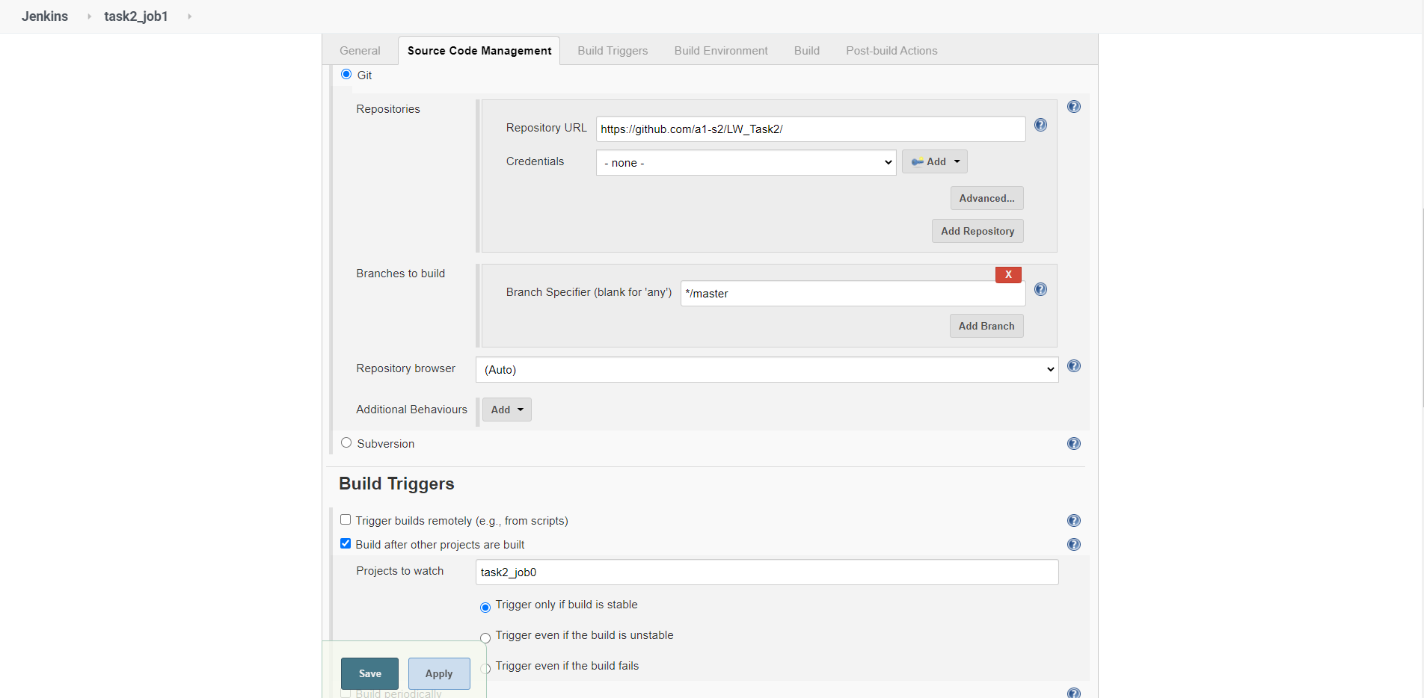

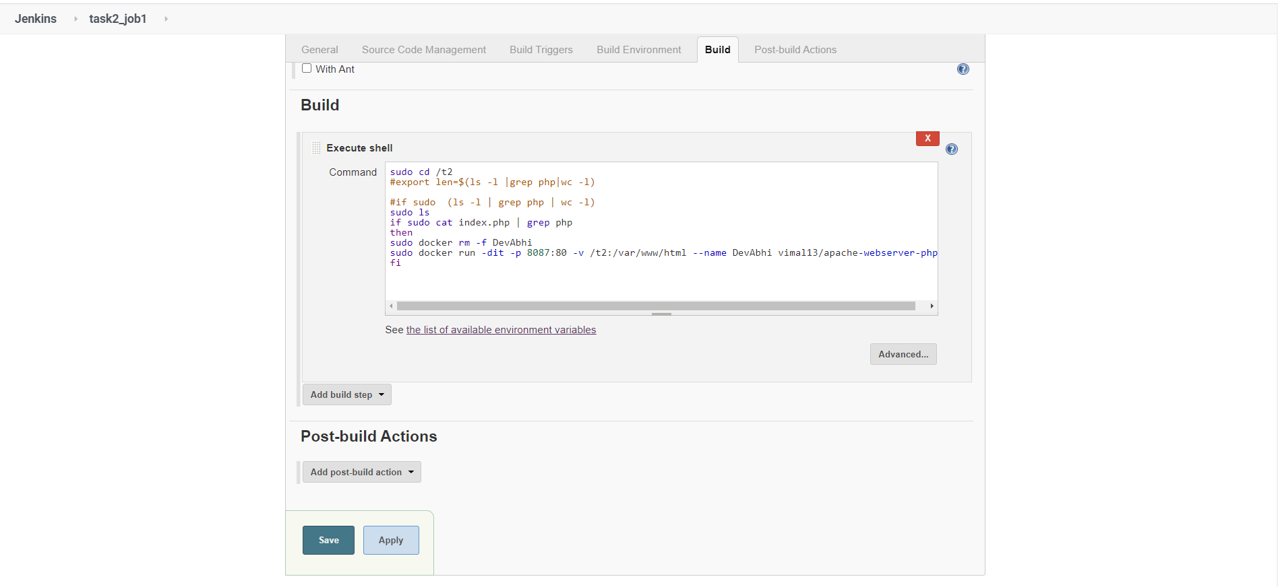

OutPut of JOB2 :-

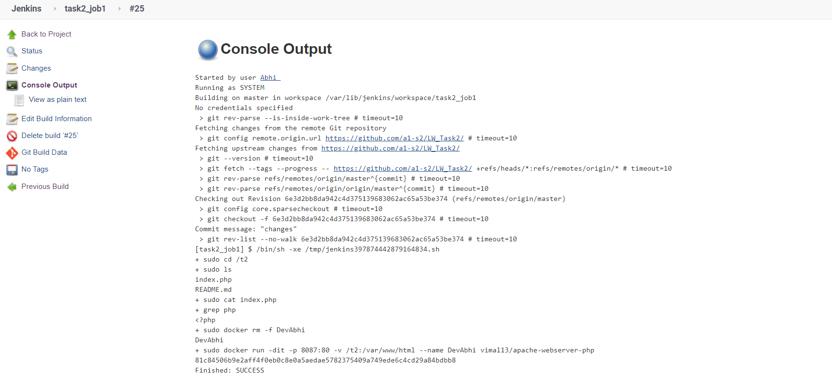

JOB 3:-

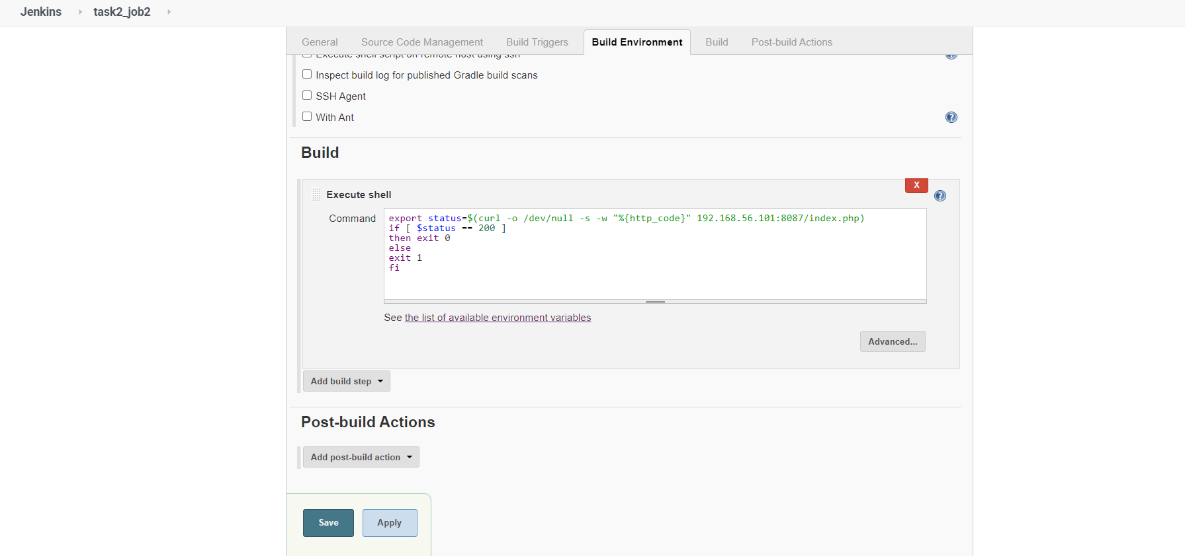

If JOB 3 Fails then it will send mail .

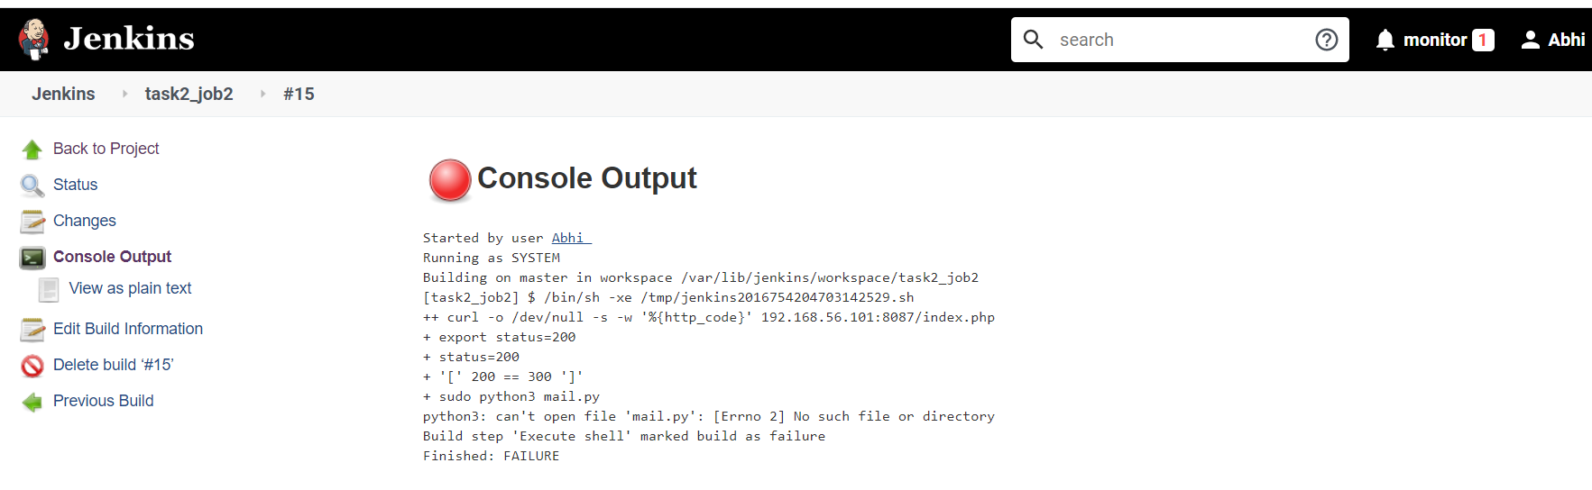

Mail of Failing Job :-

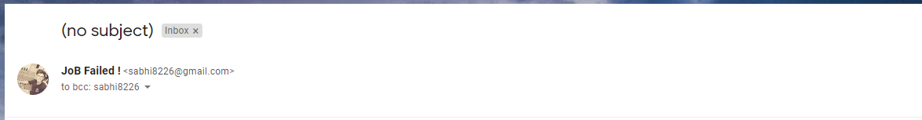

OutPut of Job 3:-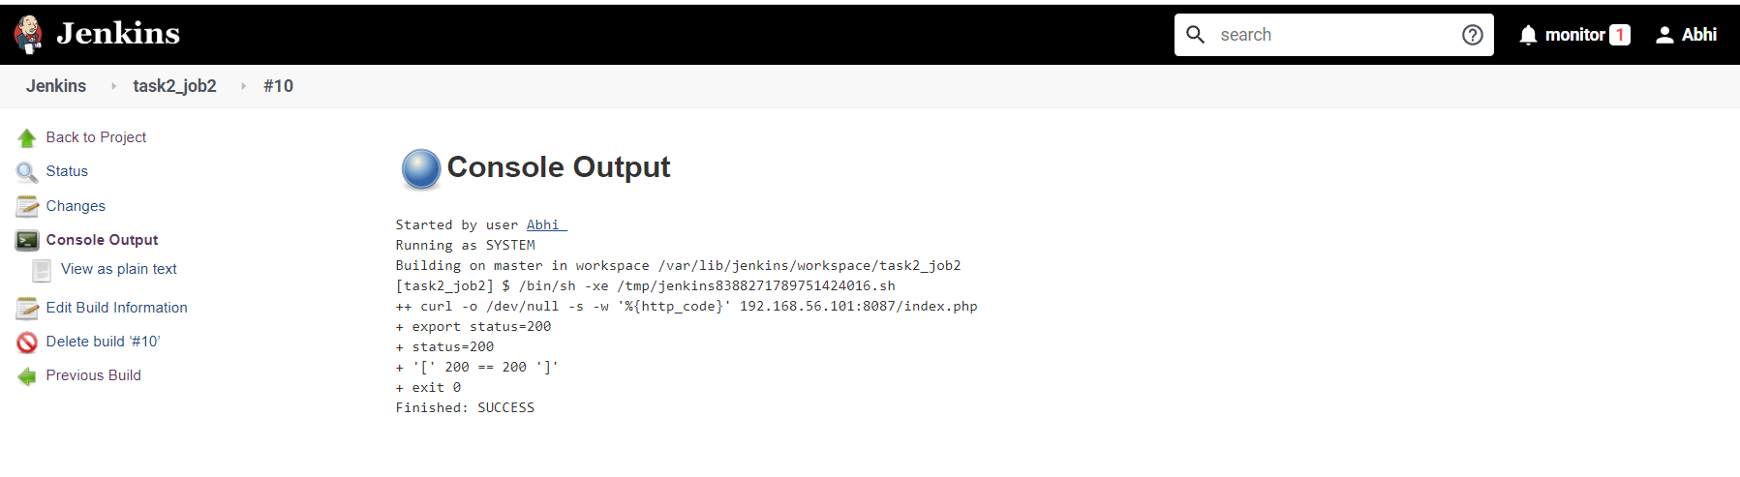

OutPut is Here :-

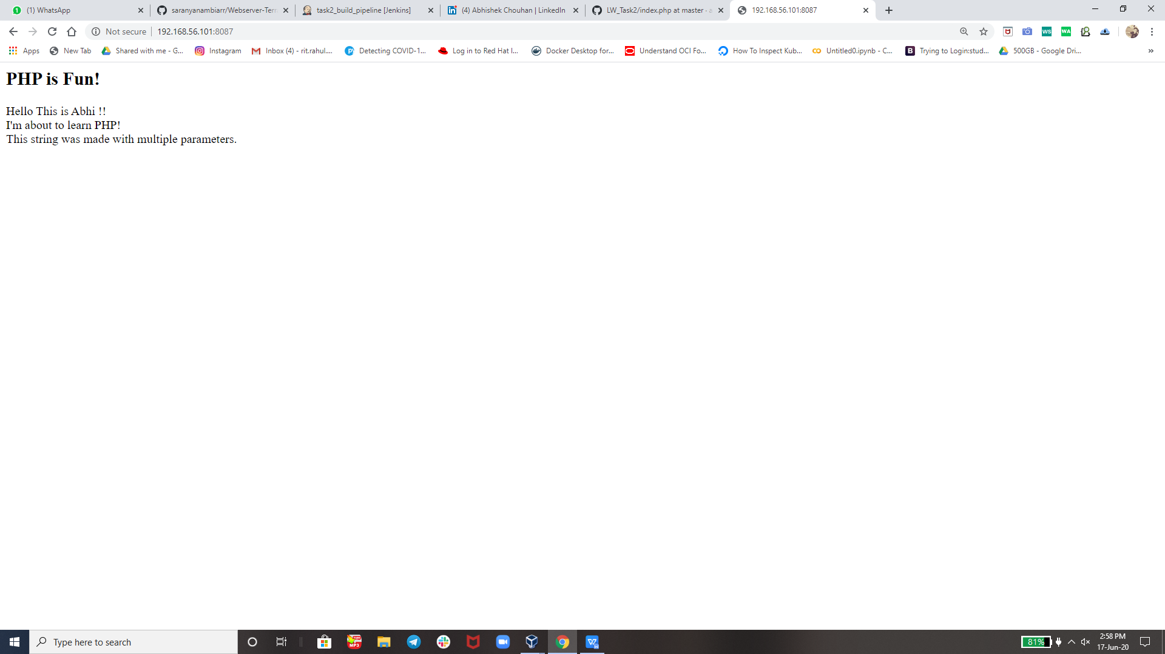

JOB 4 :-

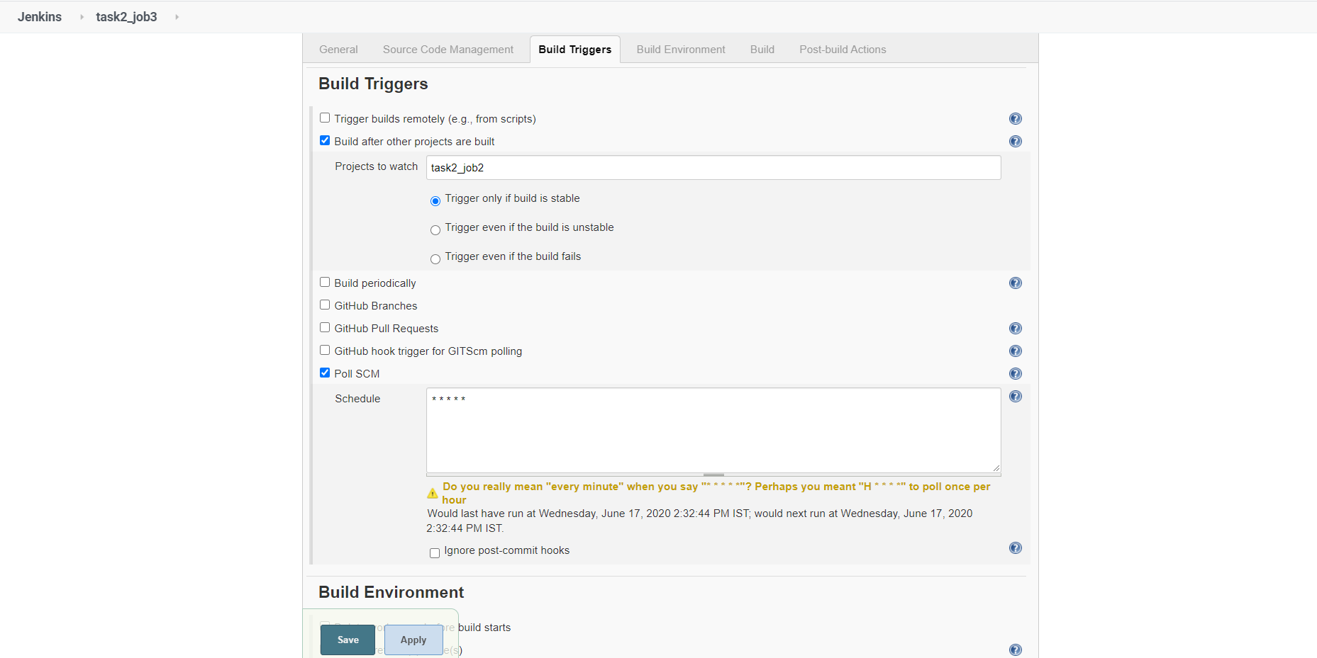

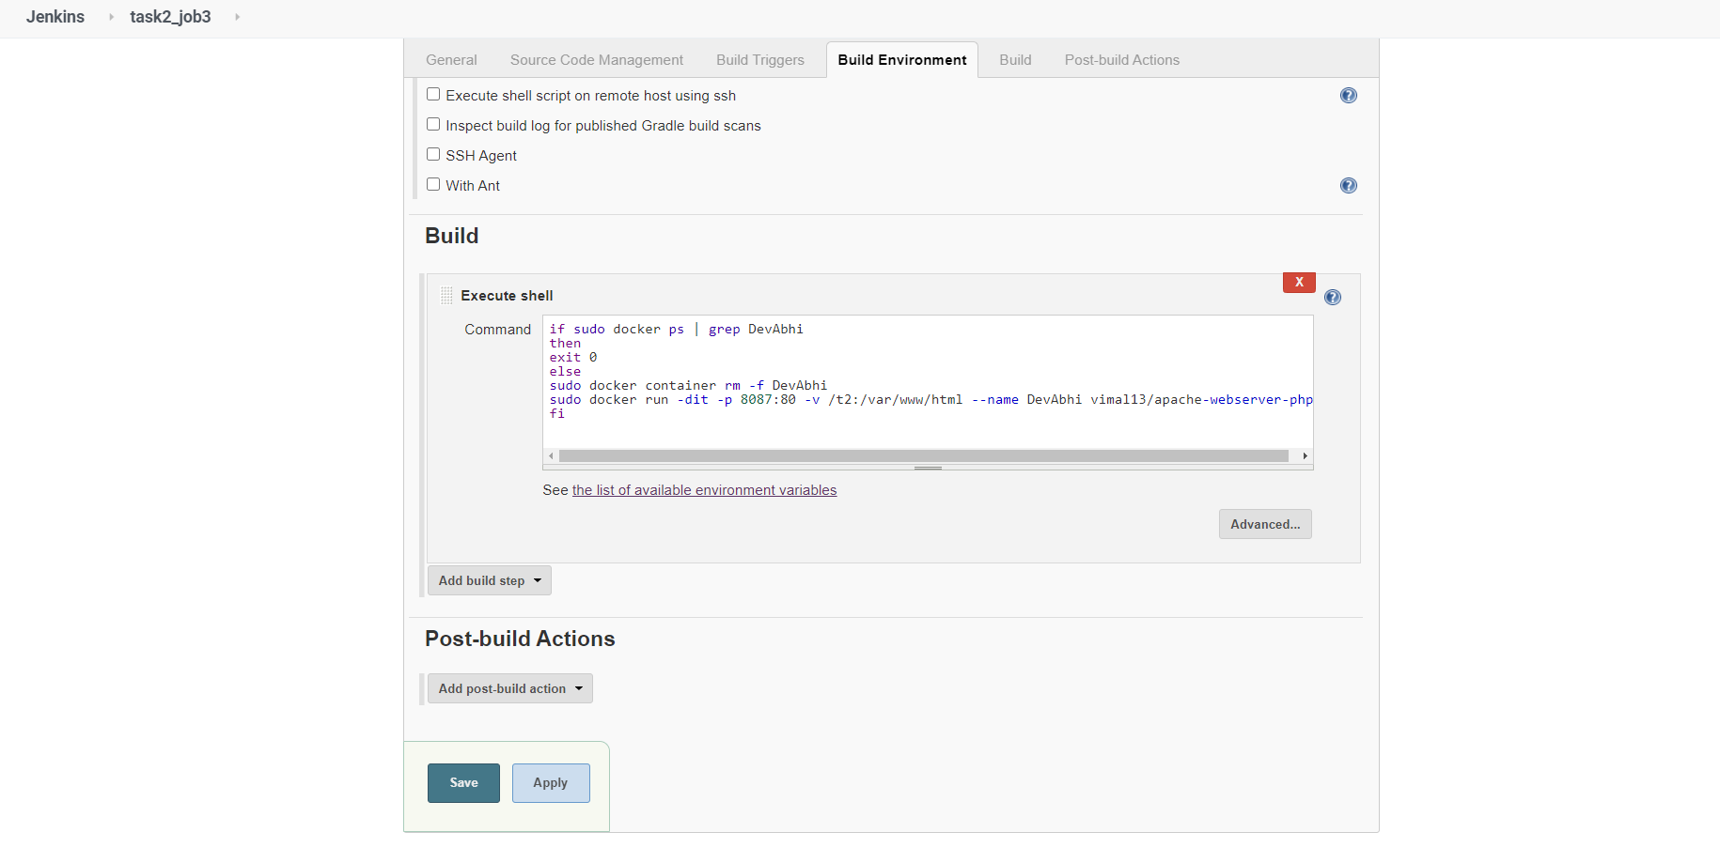

Output of Job 4 :-

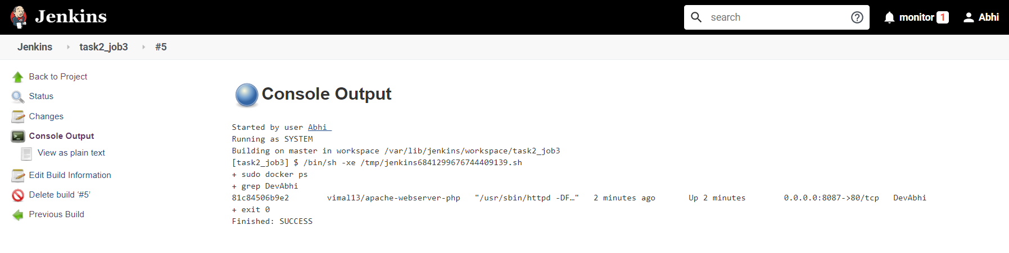

Build Pipeline View For the Whole task :-

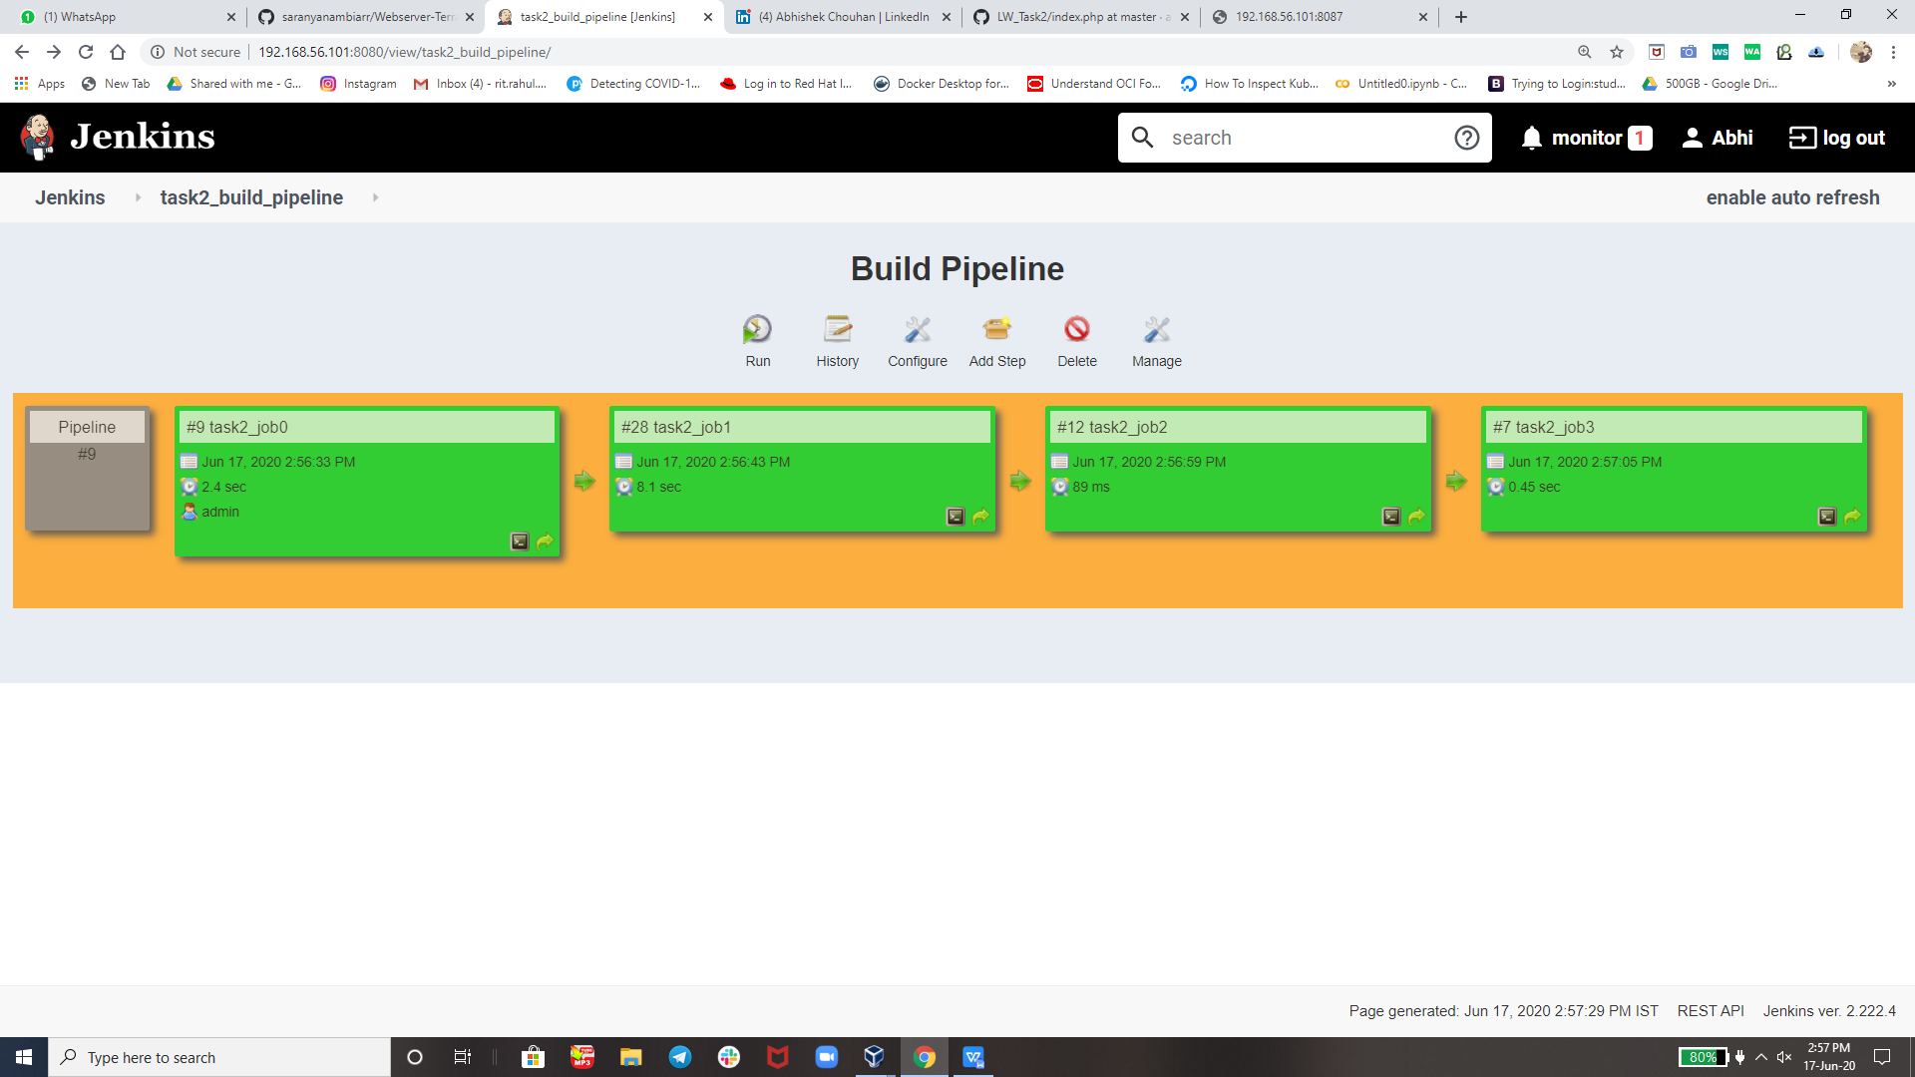

**All Thanks tO my Mentor The World Record Holder Mr. Vimal Daga Sir**

**Thank you vimal sir for teaching us such an great tools technology like RHEL 8, Jenkins, git, Docker and CreaTing Dockerfile Helped me here In this task. So that today i am capable of creating such an Great ProJecT.**

**Thank you EveryOne For Reading !**